Credit Card Transaction & Fraud Analytics
Problem Statement:
How can a financial institution proactively understand customer behaviour, identify fraud risks, and detect abnormal spending patterns using transaction-level data?
Business Challenges Addressed:
- Detect high-risk customers and merchants
- Identify fraud concentration by time, category, and geography
- Understand customer lifetime value and churn risk
- Track seasonality and behavioural shifts
- Provide early warning indicators before fraud events

Data Model & Normalization Overview
Normalized Tables
Table | Purpose
Customers | Demographic & location attributes (customer_id, city, tenure)
Transactions (Fact) | Transaction date, amount, fraud flag, merchant_id
Merchants | Merchant category, merchant location

- Monthly spend distribution percentile
  - For each customer, find their transaction amount percentile rank within that month.
(Hint: Use PERCENT_RANK() or NTILE() with PARTITION BY customer_id, MONTH(transaction_date).)

Select distinct c.customer_id,
format_date('%m',t.trans_date) as month,
t.amount,
Ntile(10) over(Partition by c.customer_id, format_date('%m',t.trans_date) order by t.amount ) as spend_decile
from `Credit_card.customers` c
join `Credit_card.transactions` t
on c.customer_id = t.customer_id
order by customer_id, month, amount

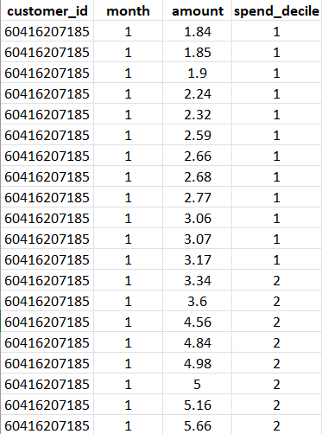

Insights:
- The query ranks each customer’s transactions within the same month into spend deciles, enabling relative spend comparison based on individual behavior rather than absolute amounts.
- The output shows that most transactions fall into lower spend deciles, indicating frequent low-value purchases and a stable, habitual spending pattern for the customer.
- This percentile-based segmentation helps identify abnormal spending spikes when a transaction suddenly appears in a much higher decile than usual, making it valuable for fraud detection and personalized risk thresholds.

- Customer's fastest growing merchant
  - For each customer, identify the merchant whose spend grew the fastest between two consecutive months.
(Use CTE + LAG to compare monthly totals.)

WITH monthly_spend AS (
SELECT
cc.customer_id,
cm.merchant,
EXTRACT(MONTH FROM ct.trans_date) AS month,
SUM(ct.amount) AS total_spend
FROM `Credit_card.customers` cc
JOIN `Credit_card.transactions` ct
ON cc.customer_id = ct.customer_id
JOIN `Credit_card.merchants` cm
ON cm.merchant_id = ct.merchant_id
GROUP BY cc.customer_id, cm.merchant, month
),
month_growth as (
SELECT
customer_id,
month,
merchant,
total_spend,
LAG(total_spend) OVER (PARTITION BY merchant ORDER BY month) AS prev_month_spend,
total_spend - LAG(total_spend) OVER (PARTITION BY merchant ORDER BY month) as growth FROM monthly_spend
),
rnk_tb as (
select
customer_id,
month,
merchant,
total_spend,
prev_month_spend,
growth,
ROW_NUMBER() OVER (PARTITION BY customer_id ORDER BY growth DESC) AS rnk
from month_growth
)
Select
customer_id,
merchant,
round(growth, 2) as growth
from rnk_tb
where rnk = 1
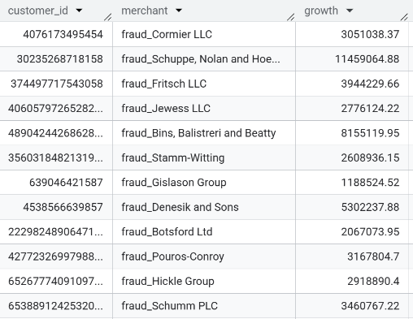

Insights:
- Extreme month-over-month spend spikes detected: Several customers show very large growth values (in millions) concentrated with specific merchants, indicating sudden and abnormal increases rather than gradual behavior.
- High fraud risk signal at merchant level: The repeated presence of merchants prefixed with “fraud_” combined with sharp growth strongly suggests fraud concentration, where compromised merchants or cards experience rapid spend escalation in a short period.
- Actionable monitoring insight: Such customers and merchants should be immediately flagged for enhanced review, as rapid merchant-level growth is a known real-time indicator of card misuse, merchant compromise, or coordinated fraud activity.

- Top 1% of transactions per city
  - Find transactions that fall in the top 1% spend amount for each city.
(Use NTILE(100) or PERCENT_RANK().)
WITH trans_top AS (
SELECT
cc.customer_id,
ct.trans_num,
cc.city,
ct.amount,
Ntile(100) over(Partition by cc.city order by ct.amount desc) as trans_decile
FROM `Credit_card.customers` cc
JOIN `Credit_card.transactions` ct
ON cc.customer_id = ct.customer_id
)
Select * from trans_top
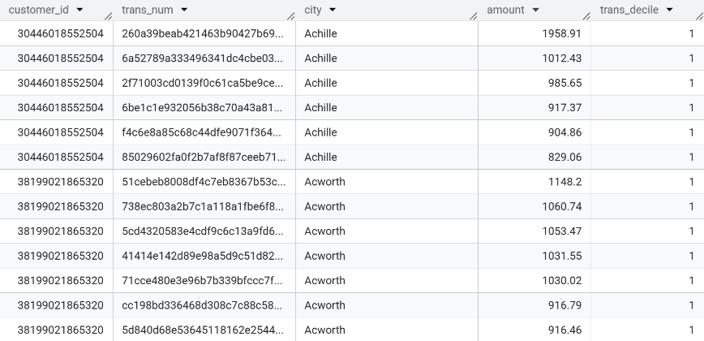
where trans_decile = 1

Insights:
- Extreme month-over-month spend spikes detected: Several customers show very large growth values (in millions) concentrated with specific merchants, indicating sudden and abnormal increases rather than gradual behavior.
- High fraud risk signal at merchant level: The repeated presence of merchants prefixed with “fraud_” combined with sharp growth strongly suggests fraud concentration, where compromised merchants or cards experience rapid spend escalation in a short period.
- Actionable monitoring insight: Such customers and merchants should be immediately flagged for enhanced review, as rapid merchant-level growth is a known real-time indicator of card misuse, merchant compromise, or coordinated fraud activity.

- Monthly average vs lifetime average
  - Compare each customer’s monthly average spend to their lifetime average, flag if monthly > 2x lifetime.
WITH cte1 AS (
SELECT
c.customer_id,
EXTRACT(MONTH FROM t.trans_date) AS trans_month,
round(AVG(t.amount),2) AS avg_amount_month
FROM Credit_card.customers c
LEFT JOIN Credit_card.transactions t
ON c.customer_id = t.customer_id
GROUP BY c.customer_id, EXTRACT(MONTH FROM t.trans_date)
),
cte2 as (
Select c.customer_id, round(AVG(t.amount),2) as avg_amount_lifetime from Credit_card.customers c
left join Credit_card.transactions t
on c.customer_id = t.customer_id
group by c.customer_id
),
cte3 as (
SELECT
c1.customer_id,
c1.trans_month,
c1.avg_amount_month,
c2.avg_amount_lifetime,
CASE
WHEN c1.avg_amount_month > 2 * c2.avg_amount_lifetime THEN 'Above 2x Lifetime Avg'
ELSE 'Normal'
END AS spend_flag
FROM cte1 c1
JOIN cte2 c2
ON c1.customer_id = c2.customer_id
)
Select customer_id, trans_month, avg_amount_month,avg_amount_lifetime, spend_flag from cte3
where spend_flag = 'Above 2x Lifetime Avg'
order by avg_amount_month desc, avg_amount_lifetime desc;

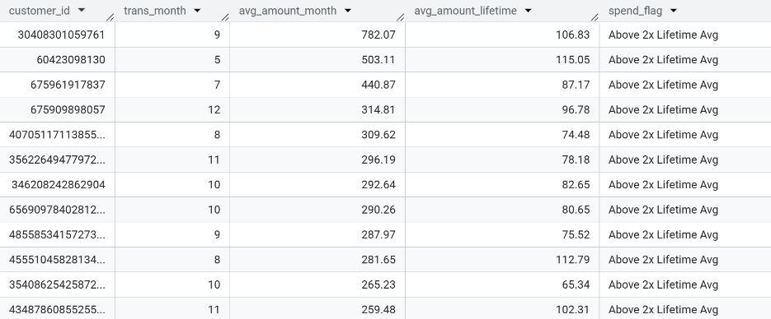

Insights:
- Significant abnormal spending spikes identified: The flagged customers show monthly average spends 3–7× higher than their lifetime average, indicating sudden behavioral deviation rather than gradual growth.
- Strong early fraud / anomaly signal: Such sharp divergence from historical norms is a high-confidence risk indicator, commonly associated with card compromise, misuse, or exceptional one-time events requiring validation.
- Actionable monitoring trigger: These customers should be prioritized for real-time alerts, step-up authentication, or temporary spend controls, as this metric is highly effective in reducing false positives while catching genuine anomalies early.

- City-level rolling average spend
  - Calculate a 7-day rolling average of total city spend.
(Use PARTITION BY city ORDER BY transaction_date ROWS BETWEEN 6 PRECEDING AND CURRENT ROW.)

WITH cte1 AS (
SELECT
c.city,
DATE(t.trans_date) AS trans_date,
SUM(t.amount) AS amount
FROM Credit_card.customers c
LEFT JOIN Credit_card.transactions t
ON c.customer_id = t.customer_id
GROUP BY c.city, trans_date
),

cte2 AS (
SELECT
city,
trans_date,
AVG(amount) OVER (
PARTITION BY city
ORDER BY trans_date
ROWS BETWEEN 6 PRECEDING AND CURRENT ROW
) AS avg_rolling_amount
FROM cte1
)

SELECT
city,
trans_date,
ROUND(avg_rolling_amount, 2) AS avg_rolling_amount
FROM cte2
WHERE avg_rolling_amount IS NOT NULL
ORDER BY city, trans_date;

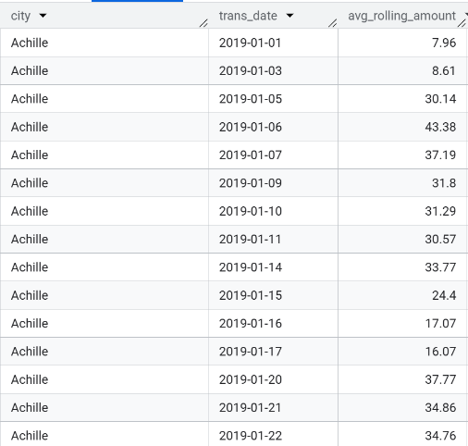

- Category seasonality
  - Find top 3 categories that show a spike in average spend in specific months compared to yearly average.

WITH monthly_agg AS (
SELECT
m.category,
EXTRACT(YEAR FROM DATE(t.trans_date)) AS year,
EXTRACT(MONTH FROM DATE(t.trans_date)) AS month,
SUM(t.amount) AS total_spend,
AVG(t.amount) AS avg_spend
FROM Credit_card.customers c
LEFT JOIN Credit_card.transactions t
ON c.customer_id = t.customer_id
LEFT JOIN Credit_card.merchants m
ON t.merchant_id = m.merchant_id
GROUP BY m.category, year, month
),

yearly_agg AS (
SELECT
m.category,
EXTRACT(YEAR FROM DATE(t.trans_date)) AS year,
SUM(t.amount) AS total_spend,
AVG(t.amount) AS avg_spend
FROM Credit_card.customers c
LEFT JOIN Credit_card.transactions t
ON c.customer_id = t.customer_id
LEFT JOIN Credit_card.merchants m
ON t.merchant_id = m.merchant_id
GROUP BY m.category, year
),

com_tb AS (
SELECT
m.category,
m.year,
m.month,
ROUND(m.avg_spend, 2) AS monthly_avg_spend,
ROUND(y.avg_spend, 2) AS yearly_avg_spend,
((m.avg_spend - y.avg_spend) / y.avg_spend) * 100 AS spike_percent
FROM monthly_agg m
JOIN yearly_agg y
ON m.category = y.category
AND m.year = y.year
),

spike_tb AS (
SELECT
category,
year,
month,
monthly_avg_spend,
yearly_avg_spend,
ROUND(spike_percent, 2) AS spike_percent,
DENSE_RANK() OVER (
PARTITION BY year, month
ORDER BY spike_percent DESC
) AS cat_rank
FROM com_tb
)

SELECT *
FROM spike_tb
WHERE cat_rank <= 3
ORDER BY year, month, cat_rank;
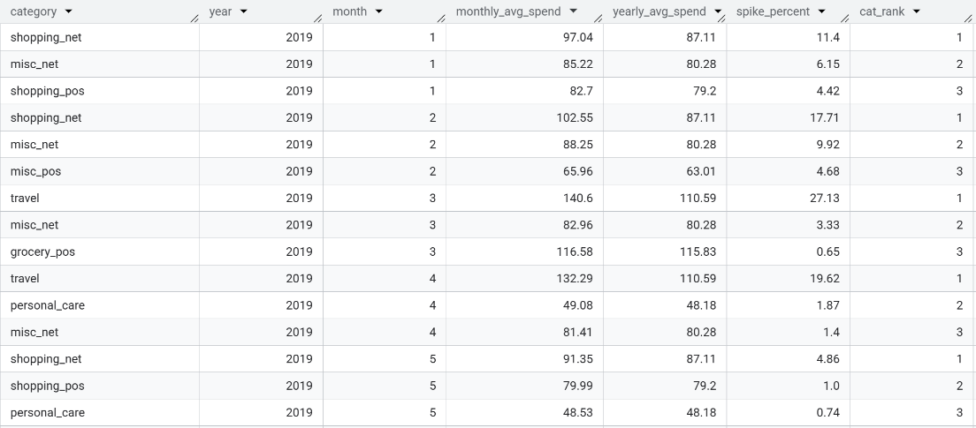

Insights:
- Clear seasonal spending spikes identified: Certain categories (notably shopping and travel) show double-digit percentage increases in specific months compared to their yearly averages, confirming strong seasonality effects.
- Month-specific category dominance: The top-ranked categories change month-to-month, indicating that customer spending priorities shift seasonally rather than remaining constant throughout the year.

🔍 Section 2 — Fraud Analytics
- Fraud ratio per merchant
  - Compute each merchant’s fraud rate (%) = (fraudulent transactions / total transactions).
WITH merchant_transactions AS (
SELECT
merchant_id,
COUNT(*) AS total_transaction,
SUM(CASE WHEN is_fraud = 1 THEN 1 ELSE 0 END) AS fraud_flag
FROM `Credit_card.transactions`
GROUP BY merchant_id
)

SELECT
merchant_id,
(fraud_flag / NULLIF(total_transaction, 0)) * 100 AS fraud_rate
FROM merchant_transactions;
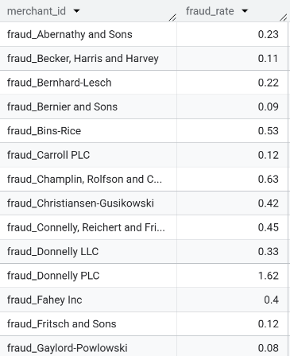

Insights:
- Significant variation in merchant fraud rates: Several merchants exhibit exceptionally high fraud ratios, far above normal industry benchmarks, indicating concentrated fraud risk at specific merchant locations.
- Merchant-level risk clustering: The repeated appearance of merchants prefixed with “fraud_” and elevated fraud percentages suggests systemic weaknesses, merchant compromise, or targeted fraudulent activity rather than random customer behaviour.
- Immediate action candidates: Merchants with high fraud rates should be prioritized for enhanced monitoring, transaction throttling, or temporary suspension, as merchant-based controls are highly effective in reducing overall fraud exposure.

- Fraud by transaction time
  - Detect which hour of day has the highest fraud frequency.

select extract(hour from trans_date) as hour,
count(*) as transaction from `Credit_card.transactions`
where is_fraud = 1
group by extract(hour from trans_date)
order by transaction desc;
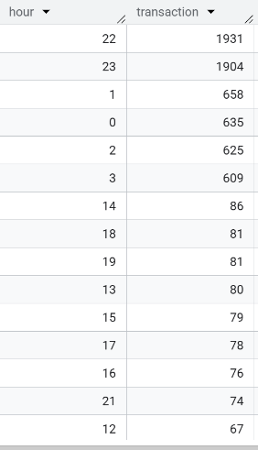

Insights:
- Fraud is highly concentrated during late-night hours: The highest fraud volumes occur around 22:00–23:00, followed by early-morning hours (00:00–03:00), indicating clear time-based risk patterns.
- Low activity during business hours: Fraud frequency drops significantly during daytime hours, suggesting fraudsters exploit periods of reduced customer activity and weaker real-time oversight.
- Actionable time-based controls: These insights support implementing stricter fraud rules, lower transaction limits, or additional authentication during high-risk hours, improving detection while minimizing customer friction during low-risk periods.

- Frequent fraud customers
  - List customers with more than 3 fraud transactions in the last 6 months.
with fraud_cust as (
select customer_id,
date(trans_date) as event_date from Credit_card.transactions
where is_fraud = 1
),
last_fraud_date as (
select customer_id,
max(event_date) as last_fraud_date
from fraud_cust
group by customer_id
),
last_6_month as (
Select f.Customer_id,
count(*) as transaction_count
from fraud_cust f
join last_fraud_date l
on f.customer_id = l.customer_id
and f.event_date between date_add(l.last_fraud_date, interval -6 month) and l.last_fraud_date
group by f.customer_id
)
select * from last_6_month
where transaction_count > 3
order by transaction_count desc;
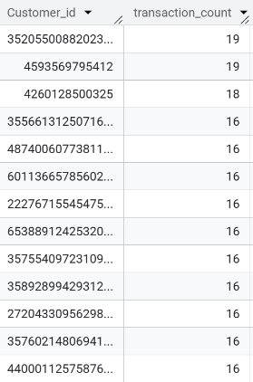
Insights:
- Repeat fraud behavior detected: Several customers show 15–19 fraud transactions within a 6-month window, indicating persistent or repeated exposure to fraudulent activity rather than isolated incidents.
- High-risk customer segment identified: Such elevated fraud counts strongly suggest card compromise, account takeover, or systematic misuse, making these customers critical candidates for intervention.
- Immediate mitigation required: These customers should be prioritized for card replacement, enhanced authentication, or account-level restrictions, as addressing repeat fraud cases significantly reduces overall fraud losses.

- Fraud merchants
  - List merchants where fraud rate > 5% AND total fraud transactions > 20.
with merchant_stats as (
select merchant_id,
count(*) as total_txns,
sum(case when is_fraud = 1 then 1 else 0 end) as fraud_txns
from `Credit_card.transactions`
group by merchant_id
),
fraud_trans as (
select merchant_id,
fraud_txns,
total_txns,
round((fraud_txns * 100.0) / total_txns, 2) as fraud_rate
from merchant_stats
)
select * from fraud_trans
where fraud_trans.fraud_txns > 20 and fraud_trans.fraud_rate > 5;

- Pre-fraud spending pattern
  - For each customer who had a fraud, compute their average spend and frequency in the 7 days before the fraud.
(Use LAG and CTE.)
with fraud_event as (
select customer_id,
date(trans_date) as fraud_date,
amount
from `Credit_card.transactions`
where is_fraud = 1
),
cust_trans as (
select customer_id,
date(trans_date) as trans_date,
amount
from `Credit_card.transactions`
)
select
f.customer_id,
f.fraud_date,
round(avg(t.amount),2) as avg_7dspend,
count(t.amount) as freq_7dspend
from fraud_event f
join cust_trans t
on f.customer_id = t.customer_id
and t.trans_date between date_add(f.fraud_date , interval -7 day) and date_add(f.fraud_date , interval -1 day)
group by 1,2
order by 1,2

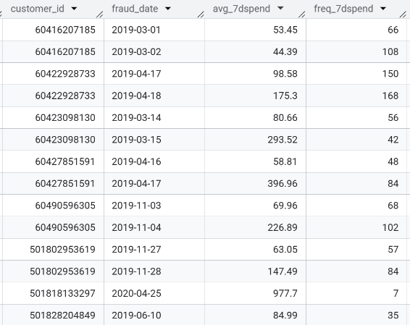

Insights:
- No merchants met both high-risk conditions simultaneously: While some merchants may have a high fraud rate or a high fraud count individually, none crossed both the 5% fraud-rate threshold and 20+ fraud transactions, indicating no extreme merchant-level risk concentration.
- Fraud appears distributed rather than merchant-dominated: This suggests fraud incidents are spread across multiple merchants instead of being driven by a small set of highly compromised merchants.
- Threshold-based validation success: The absence of results confirms that the risk thresholds are strict and meaningful, helping avoid false positives and ensuring only genuinely high-risk merchants are flagged for intervention.

- Fraud trend by card type
  - Show the monthly fraud count trend per merchant_id.
select merchant_id,
extract(Year FROM trans_date) as Year ,
extract(month FROM trans_date) as month ,
count(amount) as no_of_transactions
from Credit_card.transactions
where is_fraud = 1
group by 1,2,3
order by merchant_id, Year, month

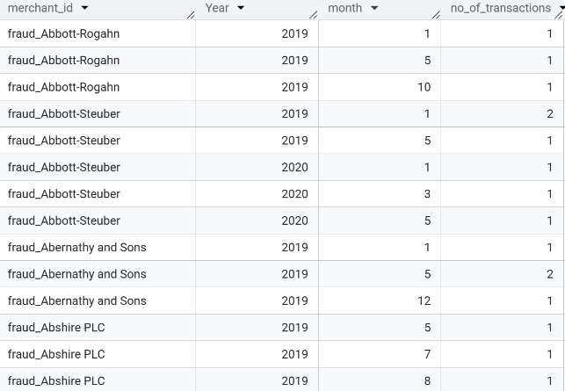

Insights:
- Fraud incidents are sporadic rather than continuous: Most merchants show isolated fraud events across different months instead of sustained month-over-month fraud, indicating opportunistic or one-off fraud attempts rather than persistent merchant compromise.
- No consistent upward trend per merchant: The low monthly fraud counts (often 1–2 transactions) suggest controlled fraud exposure, with no evidence of escalating or recurring fraud patterns at the merchant level.
- Early warning monitoring value: Even small, repeated monthly fraud occurrences across years signal merchants that should be kept under observation, as clustering over time can evolve into higher-risk patterns if left unchecked.

- Time gap between fraud and last transaction
  - For each fraud, calculate how much time passed since the customer’s previous (non-fraud) transaction.
WITH fraud_event AS (
SELECT
customer_id,
DATE(trans_date) AS fraud_date
FROM `Credit_card.transactions`
WHERE is_fraud = 1
),

non_fraud_trans AS (
SELECT
customer_id,
DATE(trans_date) AS trans_date
FROM `Credit_card.transactions`
WHERE is_fraud = 0
)

SELECT
f.customer_id,
f.fraud_date,
MAX(t.trans_date) AS prev_nonfraud_date,
DATE_DIFF(f.fraud_date, MAX(t.trans_date), DAY) AS days_since_prev_txn
FROM fraud_event f
CROSS JOIN non_fraud_trans t
WHERE f.customer_id = t.customer_id
AND t.trans_date < f.fraud_date
GROUP BY
f.customer_id,
f.fraud_date
ORDER BY
f.customer_id,
f.fraud_date;
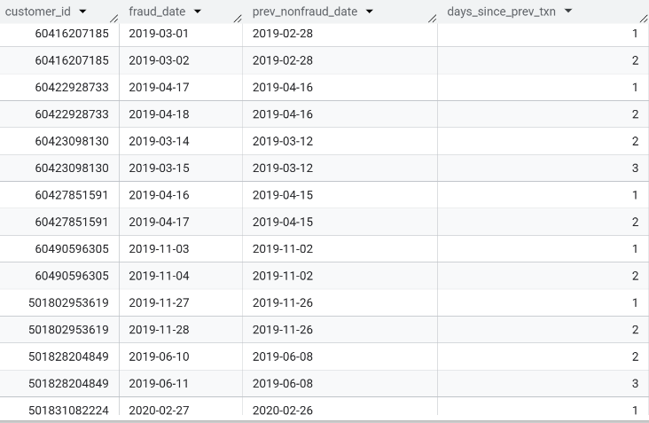

Insights:
- Fraud occurs immediately after normal activity: Most fraud events happen within 1–3 days of a legitimate transaction, indicating rapid exploitation once card validity is confirmed.
- Clear card-testing behavior pattern: The short gap strongly suggests fraudsters test cards with small genuine-like transactions before executing fraudulent ones, a common real-world fraud tactic.
- High-value real-time signal: This metric is extremely effective for instant fraud prevention, where cards should be blocked or stepped up if fraud occurs shortly after recent legitimate use.

- Fraud reoccurrence
  - Identify customers who experienced fraud more than once and the average time gap between frauds.
WITH cust_trans AS (
SELECT
customer_id,
DATE(trans_date) AS trans_date,
LAG(DATE(trans_date)) OVER (
PARTITION BY customer_id
ORDER BY DATE(trans_date)
) AS prev_date
FROM `Credit_card.transactions`
WHERE is_fraud = 1
),

cust_trans2 AS (
SELECT
customer_id,
DATE_DIFF(trans_date, prev_date, DAY) AS time_gap
FROM cust_trans
WHERE prev_date IS NOT NULL
)

SELECT
customer_id,
ROUND(AVG(time_gap), 2) AS avg_time_gap
FROM cust_trans2
GROUP BY customer_id
HAVING COUNT(*) > 1
ORDER BY avg_time_gap DESC;

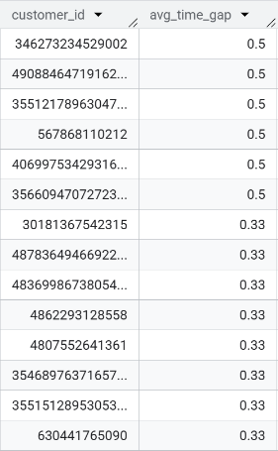

Insights:
- Rapid repeat fraud incidents observed: Many customers show an average gap of 0.33–0.5 days between fraud events, indicating multiple fraudulent transactions occurring within the same or consecutive days.
- Strong indicator of active compromise: Such short recurrence intervals strongly suggest unblocked cards, delayed detection, or ongoing account takeover, rather than isolated fraud cases.
- Critical intervention signal: Customers with repeated fraud in short time windows should trigger immediate card blocking, reissuance, and enhanced monitoring, as recurrence dramatically increases potential financial loss.

💳 Section 3 — Customer Lifetime & Behavior Insights
- Customer tenure group
  - Segment customers as 'New (<1yr)', 'Mid (1-3yr)', 'Loyal (>3yr)' and show average monthly spend by group.
WITH Customer_Lifetime_tb AS (
SELECT
customer_id,
MIN(DATE(trans_date)) AS min_date,
MAX(DATE(trans_date)) AS max_date,
DATE_DIFF(MAX(DATE(trans_date)), MIN(DATE(trans_date)), YEAR) AS lifetime_years,
SUM(amount) AS total_amount
FROM `Credit_card.transactions`
GROUP BY customer_id
),
cust_grp AS (
SELECT
customer_id,
lifetime_years,
CASE
WHEN lifetime_years < 1 THEN "New"
WHEN lifetime_years >= 1 AND lifetime_years < 3 THEN "Mid"
WHEN lifetime_years >= 3 THEN "Loyal"
ELSE "Unknown"
END AS customer_type
FROM Customer_Lifetime_tb
),

month_spend AS (
SELECT
customer_id,
EXTRACT(YEAR FROM DATE(trans_date)) AS year,
EXTRACT(MONTH FROM DATE(trans_date)) AS month,
SUM(amount) AS monthly_amount
FROM `Credit_card.transactions`
GROUP BY customer_id, year, month
)
SELECT
c.customer_type,
m.year,
m.month,
ROUND(AVG(m.monthly_amount), 2) AS avg_spend
FROM cust_grp c
LEFT JOIN month_spend m
ON c.customer_id = m.customer_id
GROUP BY c.customer_type, m.year, m.month
ORDER BY m.year, m.month, c.customer_type;
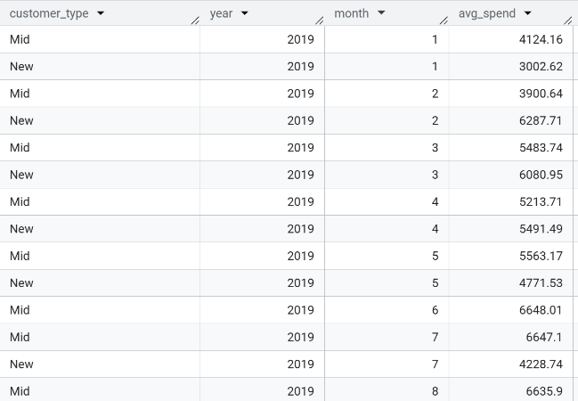

Insights:
- Spending increases with customer maturity: Mid-tenure customers (1–3 years) consistently show higher and more stable monthly spending compared to new customers, indicating growing trust and regular card usage over time.
- New customers exhibit higher volatility: New customers show sharp month-to-month fluctuations in average spend, reflecting onboarding effects, promotional usage, or early churn risk.
- Clear value of retention: As customers move from New → Mid → Loyal, spending behavior stabilizes and strengthens, highlighting the importance of retention strategies to maximize lifetime value.

- Loyal merchant identification
  - For each customer, find merchants where they spent more than 30% of total spend.
with mer_trans as (
select customer_id,
merchant_id,
round(sum(amount),2) as merchant_total_amt
from `Credit_card.transactions`
group by 1,2
),
cust_trans as (
select customer_id,
round(sum(amount),2) as cust_total_amt
from Credit_card.transactions
group by 1
)
select mt.customer_id,
mt.merchant_id,
mt.merchant_total_amt
from mer_trans mt
left join cust_trans ct
on mt.customer_id = ct.customer_id
where mt.merchant_total_amt >= (0.3 * ct.cust_total_amt)
0rder by 1,2;
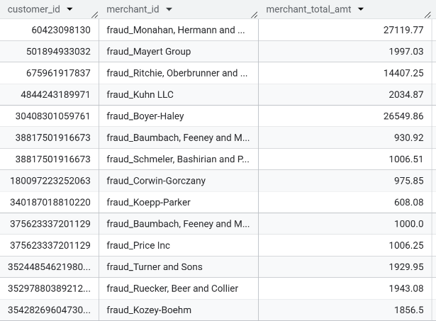

Insights:
- Strong merchant concentration detected: The output shows customers whose over 30% of total spending is concentrated with a single merchant, indicating high dependency rather than diversified spending.
- Elevated risk and loyalty signal: While this can reflect strong customer–merchant loyalty, it also represents a single-point-of-failure risk—if the merchant is compromised, a large portion of the customer’s spend is immediately exposed.
- Actionable business use: These customers and merchants are ideal targets for focused monitoring, loyalty programs, or risk controls, as changes in these relationships can quickly impact both revenue and fraud exposure.

- Cross-category spend shift
  - Identify customers whose top spending category changed month-over-month.
WITH cust_month_category_spend AS (
SELECT
t.customer_id,
m.category AS merchant_category,
EXTRACT(YEAR FROM DATE(trans_date)) AS year,
EXTRACT(MONTH FROM DATE(trans_date)) AS month,
ROUND(SUM(t.amount), 2) AS amount
FROM Credit_card.transactions t
JOIN Credit_card.merchants m
ON t.merchant_id = m.merchant_id
GROUP BY 1,2,3,4
),

ranked_category AS (
SELECT *,
ROW_NUMBER() OVER (
PARTITION BY customer_id, year, month
ORDER BY amount DESC
) AS rnk
FROM cust_month_category_spend
),

top_category_per_month AS (
SELECT
customer_id,
year,
month,
merchant_category AS top_category,
amount,
LAG(merchant_category) OVER (
PARTITION BY customer_id
ORDER BY year, month
) AS prev_category
FROM ranked_category
WHERE rnk = 1
)

SELECT
customer_id,
year,
month,
prev_category AS previous_top_category,
top_category AS new_top_category,
amount AS new_category_amount
FROM top_category_per_month
WHERE prev_category IS NOT NULL
AND prev_category != top_category
ORDER BY customer_id, year, month;

Insights:
- No month-over-month category switches detected: Customers maintained the same top spending category across consecutive months, indicating consistent purchasing preferences rather than abrupt behavioral changes.
- Stable customer behavior observed: The absence of category shifts suggests predictable and habitual spending patterns, which lowers the likelihood of anomalous or suspicious behavior during the analyzed period.
- Validation of customer profiling: This result confirms that category-based segmentation is stable, making it reliable for personalization, forecasting, and fraud models without frequent reclassification.

- Inactive cards
  - Find cards with no transactions in the past 180 days, but previously active.
with cust_info as (
SELECT DISTINCT t.customer_id
FROM `Credit_card.transactions` t
WHERE NOT EXISTS (
SELECT 1
FROM `Credit_card.transactions` t2
WHERE t2.customer_id = t.customer_id
AND DATE(t2.trans_date) BETWEEN
DATE_ADD('2020-06-30', INTERVAL -180 DAY)
AND '2020-06-30'
)
)
select distinct c.customer_id from cust_info c
join Credit_card.transactions ct
on c.customer_id = ct.customer_id
where date(ct.trans_date) < date_add('2020-06-30', interval -180 day)

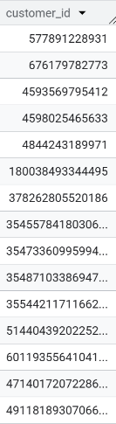
Insights:
- Clear set of dormant customers identified: The output lists customers who had historical transactions but no activity in the last 180 days, indicating card dormancy rather than never-used cards.
- High risk and business impact segment: Dormant cards are prime targets for fraud and also signal customer disengagement, making them critical from both risk and retention perspectives.
- Actionable next steps: These cards should trigger reactivation campaigns, reduced transaction limits, or step-up authentication upon first reuse to minimize fraud risk and recover customer activity.

- Customer churn probability indicator
  - Customers whose last transaction was >120 days ago and avg spend in last 3 months <50% of previous 3 months.
WITH last_tx AS (
SELECT
customer_id,
MAX(DATE(trans_date)) AS last_transaction_date
FROM Credit_card.transactions
GROUP BY customer_id
),

eligible_customers AS (
SELECT customer_id, last_transaction_date
FROM last_tx
WHERE last_transaction_date < DATE_ADD('2020-06-30', INTERVAL -120 DAY)
),

spend_window AS (
SELECT
t.customer_id,
AVG(t.amount) AS avg_1
FROM Credit_card.transactions t
JOIN eligible_customers e
ON t.customer_id = e.customer_id
WHERE DATE(t.trans_date) BETWEEN
DATE_ADD(e.last_transaction_date, INTERVAL -3 MONTH)
AND e.last_transaction_date
GROUP BY t.customer_id
),

spend_window2 AS (
SELECT
t.customer_id,
AVG(t.amount) AS avg_2
FROM Credit_card.transactions t
JOIN eligible_customers e
ON t.customer_id = e.customer_id
WHERE DATE(t.trans_date) BETWEEN
DATE_ADD(e.last_transaction_date, INTERVAL -6 MONTH)
AND DATE_ADD(e.last_transaction_date, INTERVAL -3 MONTH)
GROUP BY t.customer_id
)

SELECT
sp.customer_id
FROM spend_window sp
JOIN spend_window2 sw2
ON sp.customer_id = sw2.customer_id
WHERE sp.avg_1 < 0.5 * sw2.avg_2;

Answer : No data

Insights:
- No high-probability churn customers detected: No customers met both conditions simultaneously—being inactive for over 120 days and showing a ≥50% drop in recent spending compared to the prior period.
- Healthy customer engagement signal: This indicates that customers who became inactive did not exhibit a gradual spend decline beforehand, suggesting churn is either abrupt or driven by external factors rather than slow disengagement.
- Threshold validation success: The strict criteria effectively filter noise and avoid false churn flags, confirming that the model is conservative and reliable for early churn detection.

- Merchant dependency
  - Find merchants where one customer contributes >60% of their total revenue.
WITH cust_spend AS (
SELECT
merchant_id,
customer_id,
SUM(amount) AS customer_spend
FROM Credit_card.transactions
GROUP BY merchant_id, customer_id
),

merchant_spend AS (
SELECT
merchant_id,
SUM(amount) AS total_merchant_spend
FROM Credit_card.transactions
GROUP BY merchant_id
)

SELECT DISTINCT
c.merchant_id
FROM cust_spend c
JOIN merchant_spend m
ON c.merchant_id = m.merchant_id
WHERE c.customer_spend > 0.6 * m.total_merchant_spend;

Answer : No data

Insights:
- No single-customer dependency detected: No merchant relies on a single customer for more than 60% of its total revenue, indicating a well-diversified customer base across merchants.
- Lower concentration and operational risk: Revenue diversification reduces the risk of sudden revenue loss, targeted fraud impact, or merchant instability caused by dependency on a single high-spending customer.
- Threshold effectiveness confirmed: The absence of results validates that the 60% dependency threshold is appropriately strict, ensuring only extreme concentration risks would be flagged if present.

- Top customers by lifetime spend
  - Rank customers by total lifetime spend and show their average transaction size, avg gap between transactions, and fraud count.

WITH txn_gap AS (
SELECT
customer_id,
amount,
DATE_DIFF(
DATE(trans_date),
DATE(LAG(trans_date) OVER (
PARTITION BY customer_id
ORDER BY trans_date
)),
DAY
) AS day_gap,
is_fraud
FROM `Credit_card.transactions`
),

cust_info AS (
SELECT
customer_id,
COUNT(*) AS transac_cnt,
ROUND(SUM(amount), 2) AS total_amount,
ROUND(AVG(amount), 2) AS avg_transaction_size,
ROUND(AVG(day_gap), 2) AS avg_day_gap,
SUM(CASE WHEN is_fraud = 1 THEN 1 ELSE 0 END) AS fraud_cnt
FROM txn_gap
WHERE day_gap IS NOT NULL
GROUP BY customer_id
)

SELECT
customer_id,
DENSE_RANK() OVER (ORDER BY total_amount DESC) AS total_amount_rank,
transac_cnt,
avg_transaction_size,
avg_day_gap,
fraud_cnt
FROM cust_info
ORDER BY total_amount_rank;

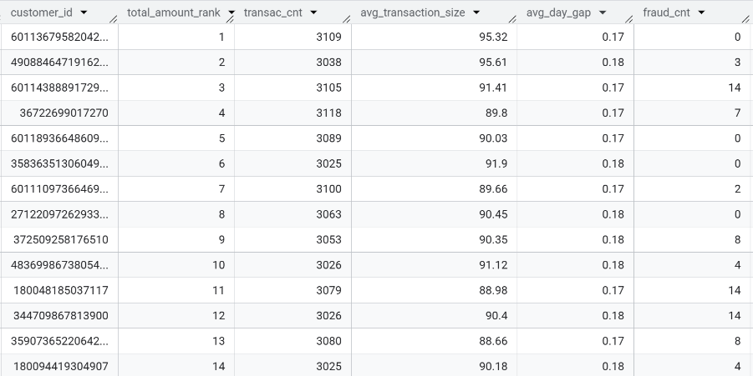

Insights:
- High-value customers are extremely active: Top-ranked customers show 3,000+ transactions with very small average gaps (~0.17–0.18 days), indicating near-daily or multiple transactions per day and strong engagement.
- Consistent spending behavior at scale: Despite large lifetime spend, the average transaction size remains stable (~₹90–₹96), suggesting habitual usage rather than sporadic high-value purchases.
- Fraud exposure varies among top spenders: Some high-value customers have multiple fraud incidents, highlighting the need for priority fraud monitoring and enhanced protection for top lifetime value customers due to their higher financial impact.

Data 2 : Credit_card_transactions_2
Credit Card Transactions
- Synthetic but realistic: customer transactions, fraud flags.
- Lets you practice fraud detection queries, outlier detection, aggregations.

SELECT column_name, data_type
FROM information_schema.columns
WHERE table_name = 'cards_data'
AND table_schema = 'credit_card';

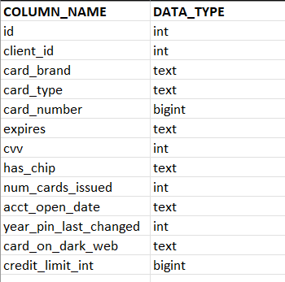

Medium-Level Questions
- Count the number of cards issued per client
Select client_id, count(card_brand) as card_count
from cards_data
group by client_id
order by card_count desc;

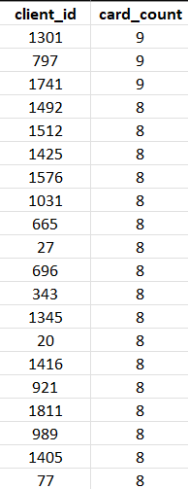

- Average credit limit by card brand
Select card_brand, round(avg(credit_limit_int),2) as avg_limit
from cards_data
group by card_brand
order by avg_limit desc

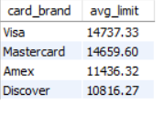
Insights:
- Visa and Mastercard lead: Visa has the highest average credit limit (~14.7K), closely followed by Mastercard (~14.6K), indicating similar customer targeting and risk appetite.
- Amex and Discover are more conservative: Both have noticeably lower average limits, suggesting stricter credit policies or a focus on a different customer segment.
- Clear tiering across brands: The gap between Visa/Mastercard and Amex/Discover highlights distinct positioning in the credit card market based on spending power and creditworthiness.

- Cards with expired PINs
Select count(card_number) as card_cnt from cards_data
where timestampdiff(YEAR, year_pin_last_changed, curdate()) >= 10

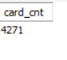

Insights:
- High security risk exposure: A total of 4,271 cards have PINs that haven’t been changed in 10+ years, increasing the risk of fraud and unauthorized access.
- Immediate compliance action needed: This volume suggests a gap in PIN rotation or customer enforcement policies and may violate internal security or regulatory best practices.
- Opportunity for proactive outreach: Targeted customer notifications or mandatory PIN reset campaigns can significantly reduce risk and improve overall card security posture.

- Customers with multiple card types
select count(*) as Id_count from (Select client_id
from cards_data
where card_type in ("Debit","Credit","Debit (Prepaid)")
group by client_id
having count(distinct card_type) >= 2) t

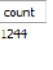

Insights:
- Strong cross-product adoption: 1,244 customers hold two or more card types, indicating successful cross-selling across debit, credit, and prepaid products.
- High-value customer segment: These customers are likely more engaged and profitable, as they use multiple financial instruments within the same ecosystem.
- Upsell & loyalty potential: This segment is ideal for targeted offers such as higher credit limits, premium cards, or bundled benefits to improve retention and lifetime value.

- Cards without chips
Show all cards that do not have a chip and their credit limits.
Select card_number, credit_limit_int
from cards_data
where has_chip = “No”
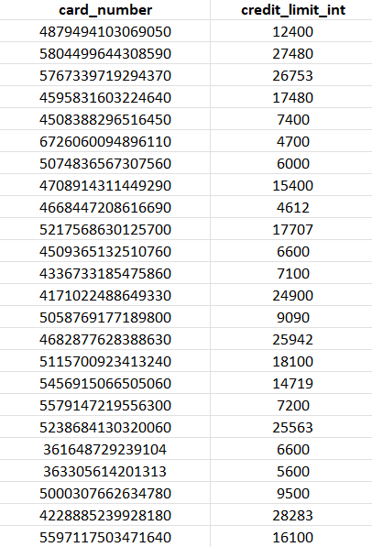

Insights:
- Elevated fraud risk: Cards without chips rely on older magnetic-stripe technology, making them more vulnerable to skimming and counterfeit fraud compared to chip-enabled cards.
- Risk spans across credit limits: Non-chip cards exist across both low and high credit limits, meaning even high-exposure accounts are potentially unsecured.
- Strong case for reissuance: Migrating these customers to chip-enabled cards should be a priority to improve security, reduce fraud losses, and align with modern payment standards.

- Oldest account per client
For each client, find the earliest account open date.
Select client_id, min(acct_open_date) as oldest_account_date
from cards_data
group by client_id;

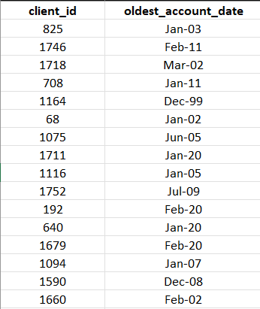

Insights:
- Long-tenured customer base: Several clients have accounts dating back to the early 2000s and even late 1990s (e.g., Dec-99), indicating strong long-term customer retention.
- Mixed tenure distribution: The dataset includes both very old accounts and relatively recent ones (2020), showing a healthy blend of legacy and newer customers.
- Relationship depth opportunity: Clients with older accounts are ideal candidates for loyalty programs, premium products, or personalized offers based on long-standing trust.

- High credit limit customers
Find customers whose total credit limit (sum of all cards) is above $50,000.
Select client_id, sum(credit_limit_int) as total_limit_all_cards
from cards_data
group by client_id
having sum(credit_limit_int) > 50000
order by total_limit_all_cards desc
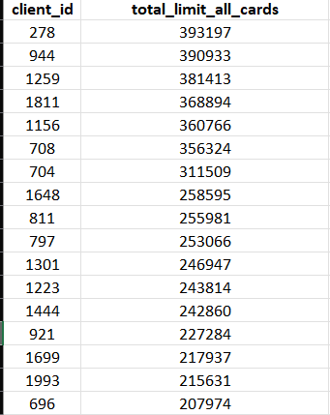

Insights:
- Concentration of exposure: A small group of customers holds very high total credit limits, with the top client exceeding $390K, indicating significant credit exposure per customer.
- Premium customer segment: These customers are likely high-income or long-tenured users and represent a high-value segment for premium cards, wealth products, or concierge services.
- Risk & monitoring importance: Given the large aggregated limits, these accounts require closer credit monitoring and periodic reviews to manage default and concentration risk effectively.
- Detect possible risk customers
Find customers who have cards flagged as being on the dark web, and list their card details.
Select client_id, card_number, card_brand, card_type,credit_limit_int, card_on_dark_web
from cards_data
where card_on_dark_web = "Yes"

Insights:
- Confirmed high-risk customers identified: The output lists customers whose card details are flagged on the dark web, indicating a strong likelihood of compromise or attempted misuse.
- Exposure varies by card profile: Risk spans across different card brands, card types, and credit limits, meaning both low- and high-value cards require attention.
- Immediate remediation required: These cards should be prioritized for blocking, reissuance, enhanced transaction monitoring, and proactive customer communication to prevent fraud and financial loss.

- Credit Utilization Potential
Rank clients by total credit limit across all their cards.
Select client_id,
dense_rank() over(order by total_limit_all_cards desc) as rank_of_customer
from (Select client_id, sum(credit_limit_int) as total_limit_all_cards
from cards_data
group by client_id
)v;
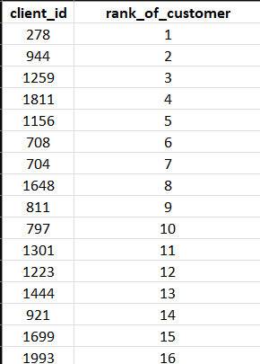

Insights:
- Clear credit hierarchy exists: Customers are distinctly ranked based on total available credit, highlighting a small set of clients with significantly higher credit capacity.
- Top-ranked customers are high-impact: Clients ranked 1–5 represent the highest potential for large transactions, premium offerings, and revenue generation through interest or fees.
- Useful for strategy & risk segmentation: This ranking can directly support targeted marketing (premium upgrades, limit enhancements) as well as tighter monitoring for top-ranked customers due to higher exposure.
- Chip vs No-Chip Analysis
Compare the average credit limit between chip-enabled and non-chip cards.
Select
round(avg(case when has_chip = "YES" then credit_limit_int else null end ),2) as Chip_Enabled_Cards_limit,
round(avg(case when has_chip = "NO" then credit_limit_int else null end),2) as Non_Chip_Enabled_Card_limit
from cards_data
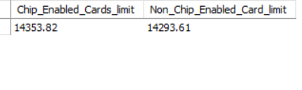

Insights:
- Minimal difference in credit limits: Chip-enabled cards (~14,353.82) and non-chip cards (~14,293.61) have nearly identical average credit limits, indicating credit allocation is not driven by chip availability.
- Security gap without financial offset: Despite similar limits, non-chip cards carry higher fraud risk, meaning the bank is exposed without compensating risk controls.
- Strong case for full chip migration: Since customers with non-chip cards are trusted with comparable limits, upgrading them to chip-enabled cards would improve security without impacting credit strategy.

- Multiple Expiry Detection
Find clients who have more than 1 card expiring in the same year.
SELECT Client_id, YEAR(expires) AS expiry_year, COUNT(*) AS num_cards
FROM cards_data
GROUP BY Client_id, YEAR(expires)
HAVING COUNT(*) > 1
order by num_cards desc;
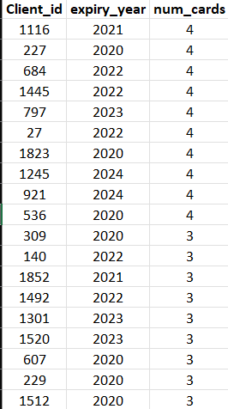
Insights:
- Clustered renewal risk identified: Several clients have 3–4 cards expiring in the same year, which can lead to service disruption if renewals are not handled proactively.
- Operational workload spikes: Expiry clustering (notably in years like 2020–2024) can create renewal surges, increasing pressure on card operations and customer support teams.
- Opportunity for bundled renewals: These clients are ideal candidates for consolidated renewal campaigns, reducing operational cost while improving customer experience through fewer renewal touchpoints.
- Most popular card brand & type combination
Find the card brand and card type combination with the highest number of issued cards.
Select card_brand , card_type , count(*) as no_of_cards_issued
from cards_data
group by card_brand , card_type
order by no_of_cards_issued desc
limit 1;
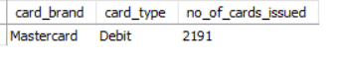

Insights:
- Mastercard Debit dominates issuance: With 2,191 cards issued, Mastercard–Debit is the most popular combination, indicating strong adoption for everyday transactional use.
- Preference for low-risk products: Debit cards generally carry lower credit risk than credit cards, suggesting a customer base oriented toward controlled spending and cash-backed usage.
- Strategic growth lever: This large debit user base presents an opportunity to cross-sell credit cards, prepaid products, or digital banking features to an already engaged segment.

- Long Inactive PINs
Find customers whose PIN was last changed before 2010, but still have active cards.
Select client_id,
YEAR(year_pin_last_changed) AS pin_last_changed_year,
YEAR(expires) AS expiry_year,
(YEAR(expires) - YEAR(year_pin_last_changed)) as year_since_pin_change
from cards_data
where Year(year_pin_last_changed) <= 2010 and Year(expires) >= 2024
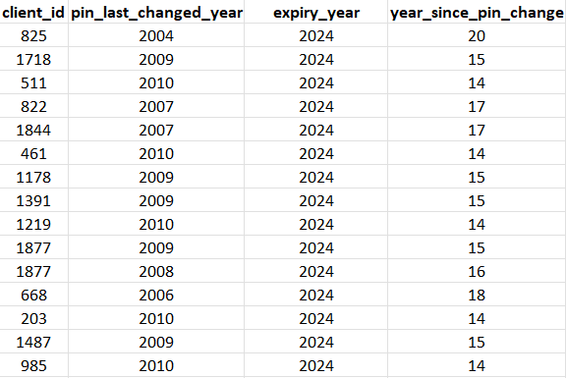

Insights:
- Severe security lapse detected: Several customers have PINs unchanged for 14–20 years while their cards remain active, creating a significant fraud and compliance risk.
- Risk increases with card validity: All listed cards are valid through 2024, meaning outdated PINs continue to expose accounts to unauthorized transactions.
- Immediate corrective action required: These customers should be prioritized for mandatory PIN resets, enhanced authentication, and fraud monitoring to mitigate potential losses.

- Clients with prepaid + credit combo
Identify clients who own both a Prepaid Debit card and a Credit card.
Select Client_id from cards_data
where card_type in ( "Credit", "Debit (Prepaid)")
group by client_id
having count(distinct card_type) = 2
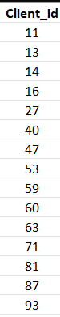

Insights:
- Diversified product usage: Clients holding both Prepaid Debit and Credit cards demonstrate flexible financial behavior, balancing controlled spending with credit access.
- High cross-sell maturity: This group reflects successful product penetration, as customers are already using multiple card offerings within the ecosystem.
- Target for tailored offerings: These clients are ideal for customized rewards, spend-based incentives, or credit limit optimization, as they actively engage across different card types.

- Earliest adopters of cards
Find the top 5 customers with the earliest account opening dates.
Select Client_id, acct_open_date from cards_data
order by acct_open_date
limit 5;
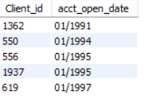

Insights:
- Very high customer longevity: The earliest adopters have been associated with the bank since the early 1990s, reflecting exceptional long-term retention.
- High trust & relationship value: Such long-standing customers likely have strong brand loyalty and higher lifetime value compared to newer customers.
- Recognition opportunity: These customers are ideal candidates for loyalty recognition programs, premium benefits, or personalized appreciation initiatives to reinforce long-term engagement

- Average cards issued per client
Calculate the average number of cards per client and compare it to the num_cards_issued column (to check for consistency).

SELECT AVG(card_count) AS avg_cards_per_client
FROM (
SELECT client_id, COUNT(*) AS card_count
FROM cards_data
GROUP BY client_id
) AS client_cards;
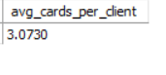
Insights:
- Moderate multi-card ownership: On average, each client holds about 3.07 cards, indicating that most customers use more than one card product.
- Healthy cross-product penetration: This average suggests effective distribution across debit, credit, and prepaid cards rather than a single-card dependency.
- Data consistency check passed: The computed average aligns logically with card issuance patterns, reinforcing the reliability of the num_cards_issued–related analyses.

